MCV4U Unit 3 Assignment Name:_________________

- Given the graph of f ’(x),

- Sketch a possible graph of y = f (x) on the same grid.

- State the intervals of increase and decrease for the function f (x) you drew.
[5]
Graph of f ’(x) = -2x + 2  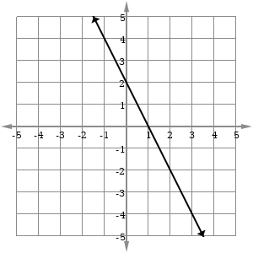 | [5]  Interval(s) where f(x) is increasing:  Interval(s) where f(x) is decreasing:

- Explain why more than one drawing is possible for f(x).

- Given the graph of f ’’ (x),

- Sketch a possible graph of y = f (x) on the same grid.

- State the intervals of concavity point of inflection for the function f (x) you drew.
[5]

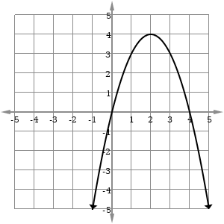 | Interval(s) of concave up:  Interval(s) of concave down:  Point(s) of inflections:

- For the following graph f(x), state the following intervals or points where the graph is:
(Approximate values are ok)
[5]
- f(x) = 0  - f(x) > 0  - f(x) < 0  - f ’(x) = 0  - f ’(x) > 0  - f ’(x) < 0  - f ’’(x) = 0  - f ’’(x) > 0  - f ’’(x) < 0 | 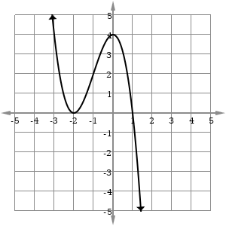

- Given $f\left(x\right)=\frac{1}{4}x^{4}-x^{3}+4x$ determine the intervals of concavity.  [4] | - On the given graph, label all local max, local min, absolute max and absolute min.  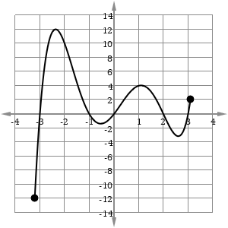  [4]

- a) Determine the local and absolute extreme values (local max, local min, absolute max and absolute min) of the function on the given interval.
f(x) = x³ – 9x² + 24x + 1, -2 $≤$ x $≤$ 6

[5]

- How would your answer to a) change if the domain was changed to 3 $≤$ x $≤$ 6

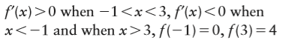
- Sketch a continuous graph that satisfies the following set of conditions:

[2]

